**User Manual**

To use the KKSR mobile app, you must first have certain software installed as the app is dependent on Firebase, Ionic, and Angular libraries (and in the future, Cordova).

1. Install NodeJS from <https://nodejs.org/en/download>
2. Download the src folder from where it’s stored
3. In command prompt (or terminal), go to the projects directory (called KKSR).
4. Run the command npm install -g ionic cordova firebase-tools (if npm is not recognized, open command prompt with npm)
5. Build the project by running the command ionic build -prod
6. Check KKSR/src/app/app.component.ts to check if all imported libraries are installed

(editors such as Visual Studio Code will throw an error under uninstalled libraries)

1. A firebase project needs to be created to host the project. Follow along with the guide at <https://firebase.google.com/docs/web/setup>
   1. A config object in order to link the project to your firebase project. The object can be found in KKSR/src/app/environments/environment.ts
2. The hosting URL will appear in the command prompt

**Use**

**(Regular User)**

User Home Page

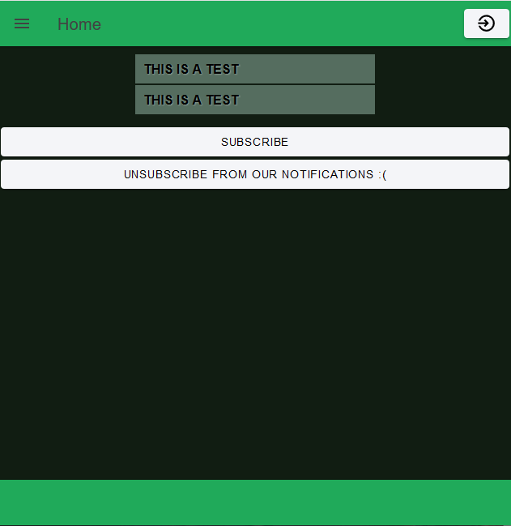

**Navigation**

Click here to open the navigation bar

**Messages**

These messages are pulled directly from the ‘Messages’ Tree in the firebase database, you can click them and see who wrote it, and what time it was written (Time is undefined as of right now)

**Sign In**

Click here to be navigated to admin-login.html

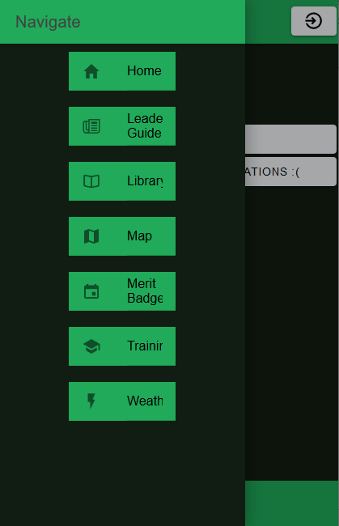

**Weather**

Clicking here will navigate you to the weather .html page and it will display the weather in Cherokee Village, AK (Closest town to KKSR)

**Merit Badge Button**

For the scope of the project, the manual will be covering the merit badges tab extensively.

All the other buttons will navigate you to a .html page, but the functionality isn’t necessarily there

**Search by Area:**

Both values are necessary to search for merit badges. It displays the merit badges from the selected camp (but only in the designated area) For example: No sports merit badges will be presented when searching for a scoutcraft merit badge

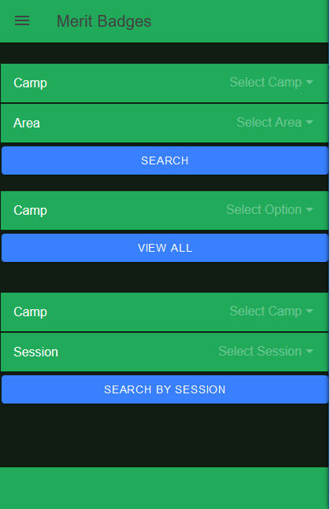

**Search by Session:**

This option displays all data that shares the same session that is submitted. The session is important so you can see what merit badges are going on at the same time (future work will consist of displaying merit badges that are also 2 or 3 hours long and that have a different sessionID so you can see that they are still going on at the same time

**View All:**

All the merit badges stored in the selected option’s tree will be presented (in alphabetical order)

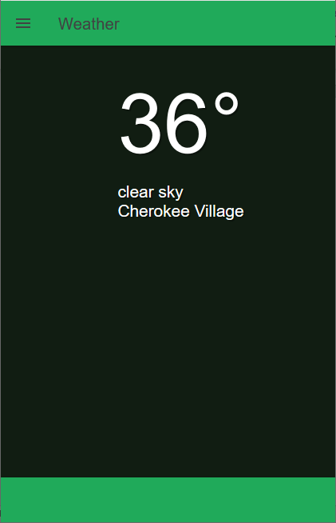

The weather page is based on an object that is returned from the openweathermap api (free version), so it will only return the actual weather at the time.

A paid for API will be able to return much more information (hour by hour or day by day).

**Admin User**

**Back button:** will return you back to the home page (this page is accessed from pressing the white icon in the top right corner of the home.html page)

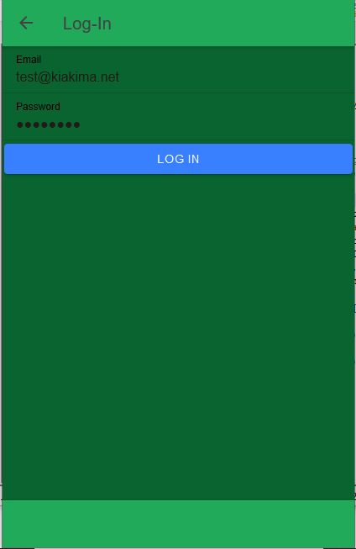

**Log-in:**

Log-in authorization is done through firebase. Notice that there is no ‘forget password’ or ‘register’ options. All information is hard-coded into firebase’s authorization tab by app owner.

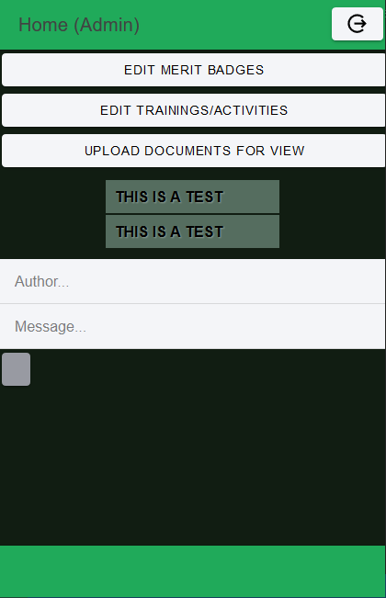

These two fields will hold the data that an admin-user wants to push to ‘message’ tree in database and all users can see

This button will submit (**WARNING:** Can input multiple times, will enter an empty message that can (and will) be passed to database.

**Log-Out ->** This button will return you back to the regular user home page.

Directs to admin-scheduling.html to add/edit merit badges

Directs to admin-trainings.html to add/edit trainings and open activities

Redirects to upload.html to allow admin-users to upload files to Storage in Firebase

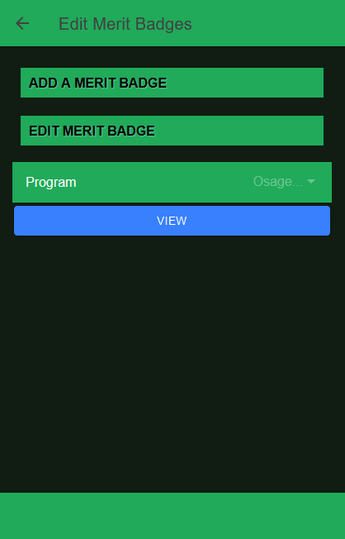

**Back button:** Goes to admin.html

Opens up a form to add a merit badge to a chosen camp. Once all data is in the form, click the submission box at the body of the expanded window (scroll down)

**Edit** (**see below**)

**View:** Prints off all merit badges for a specific camp (in alphabetical order), Default is Osage too not cause any discrepancies with pulling and causing a deletion of the whole tree

(**See below diagrams)**

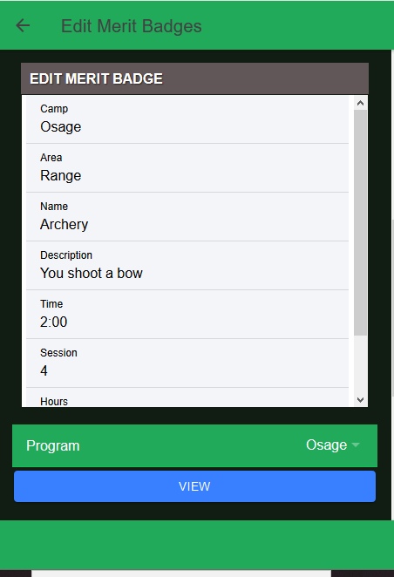

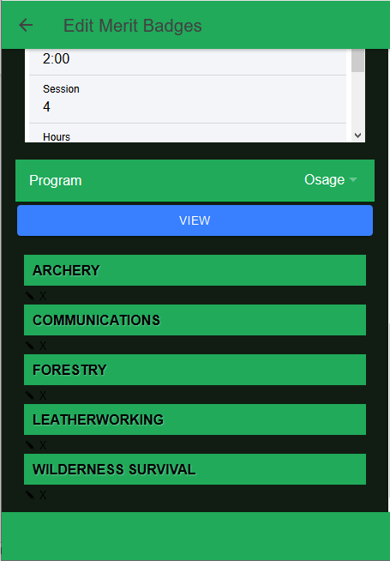.

**Delete Button:** When clicked (and confirmed), the entry is deleted entirely from the database (**Warning:** Action cannot be undone)

**Edit Button:** When clicked (and confirmed), the merit badge and its values are inserted into the edit tab (click to open), once any value is changed, click the submit button at the bottom of the expanded tab. Check the merit badge tab to see your changed information.

N**ote:** When an admin-user signs out of his login and gets redirected back to the home page. It is impossible for him to back up (and concurrently log back in) into the admin only pages. He must go through the sign in process again to access those web pages.

**Administration and Maintenance**

Due to the frequent updates to Ionic, Cordova, and Angular libraries; deprecations and bugs may be caused due to these updates, and certain features become out of date. It is always wise to routinely check through your web pages with your console open to check for any warnings and errors (right click on your web page and click **Inspect Element** and select the **Console** tab). Most changes that will need to be made are Import libraries being changed just slightly, where a certain function imported either no longer exists or change its name and input elements. Checking online for new documentation is the best way to get your app back in full functionality.

Possible enhancements that can be included is a better integration of the Cordova libraries. With this integration, you can easily create functions for toast controls and opening documents (from browser or smart phones) to utilize the full purpose of the app.